Unit 1 Family Support Materials
Get acquainted with the topics and concepts your student will be learning during Unit 1.

Linear Equations

In this unit, your student will analyze constraints on different quantities. For example:
- The amount you spend on a bicycle may be limited by how much you have saved.
- To qualify for a sports team, your child may need to practice a minimum number of hours.

Here are some ways to write constraints using mathematical notation
Real-World Constraint | In Symbols
An apartment building only allows dogs that weigh less than 20 pounds. | $$w<20$$
A casserole recipe calls for four cups of vegetables. You have mushrooms, green beans, and broccoli. | $$m+g+b=4$$
For a concert to be performed, the artists need to be sure of $1,000 in ticket sales. Tickets for children under 18 are $12.50, and tickets for adults are $15. | $$12.5c+15a ≥ 1,000$$
You need $1.50 in coins for a parking meter. You have a bunch of nickels and dimes in your pocket. | $$5n+10d=150$$
For the parking meter situation, we can see that using more dimes to make $1.50 means that we can use fewer nickels, and vice-versa. A graph allows us to see this relationship even more clearly.
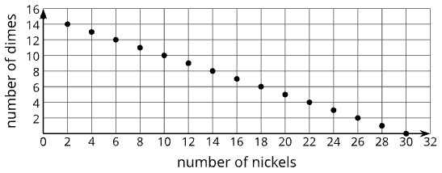
Each point on the graph represents a combination of nickels and dimes that totals $1.50. For example, if you use 8 nickels (worth $0.40), you will need 11 dimes (worth $1.10).

Apply

Try this task with your student
Priya is saving money to go on an overnight school trip.
- The cost of the trip is $360.
- She has a job at a convenience store, which pays $9 per hour
- When she babysits for a family in her neighborhood, she earns $12 per hour.
The equation $9x+12y=360$ represents all the combinations of hours Priya could work at each job and earn a total of $360. Here is a graph showing those combinations:
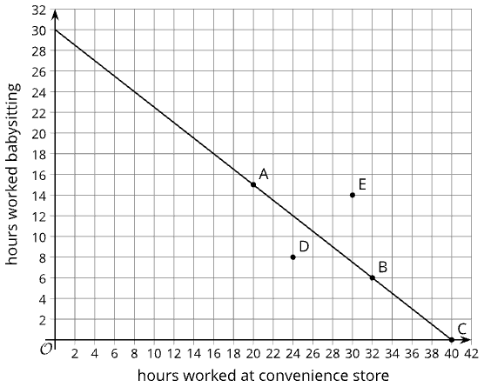

Complete the following questions
- What are the coordinates of point $A$?
- What does it tell us about the number of hours Priya worked at each job?
- Answer the same questions about points $B$ and $C$.
- Point $D$ is not on the line. How should we interpret point $D$?
- Point $E$ is not on the line. How should we interpret point $E$?
*You can find the answers on the next page

Hide the answers until you have attempted the questions
- (20, 15)
- Priya works 20 hours at the convenience store and 15 hours babysitting.
- Point $B$: (32, 6). Priya works 32 hours at the convenience store and 6 hours babysitting. Point $C$: (40, 0). Priya works 40 hours at the convenience store and does not babysit at all.
- Priya does not make enough money. She works 24 hours at the convenience store and 8 hours babysitting. She makes only $312, since $24∙9+8∙12=312$.
- Priya makes more than enough money: $438. She works 30 hours at the convenience store and 14 hours babysitting. $30∙9+14∙12=438$.

Review

Video lesson summaries for Unit 1: Linear Equations
Each video highlights key concepts and vocabulary that students learn across one or more lessons in the unit. The content of these video lesson summaries is based on the written Lesson Summaries found at the end of lessons in the curriculum. The goal of these videos is to support students in reviewing and checking their understanding of important concepts and vocabulary.

Here are some possible ways families can use these videos:
- Keep informed on concepts and vocabulary students are learning about in class.
- Watch with their students and pause at key points to predict what comes next or think up other examples of vocabulary terms

Video Title | Related Lessons
Building a Model | - Exploring Expressions and Equations  - Writing Equations to Model Relationships, Part(s) 1 & 2
Solutions to Linear Equations | - Equations and Their Solutions  - Equations and Their Graphs  - Equivalent Equations
Rewriting Equations | - Explaining Steps for Rewriting Equations  - Choosing the Correct Variable to Solve For, Part(s) 1 & 2
Equations and Their Graphs (stop video at 4:25) | - Connecting Equations to Graphs, Part(s) 1 & 2  - Writing the Equation of a Line  - Lines from Tables and Graphs  - Writing Equations of Parallel and Perpendicular Lines

 | If needed, access the digital version of this page at https://openstax.org/r/unit1-family

